Q1：

Q2：

a)

b)

c)

d)

-10.09

e)

10=10.09\*x

->

X=10/10.09

Q3:

a)

Y=0.1781\*x+0.6578

b)

Residual standard error: 0.2873 on 9 degrees of freedom

c)

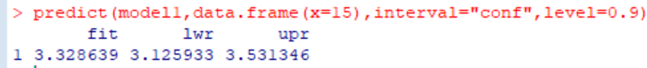

d)

0.534169

Q4:

a)

b)

c)

